**Simran Jobanputra**

**Assignment 6**

**PUI**

**1. New Shopping Cart Page**

a. Low-Fi Prototype

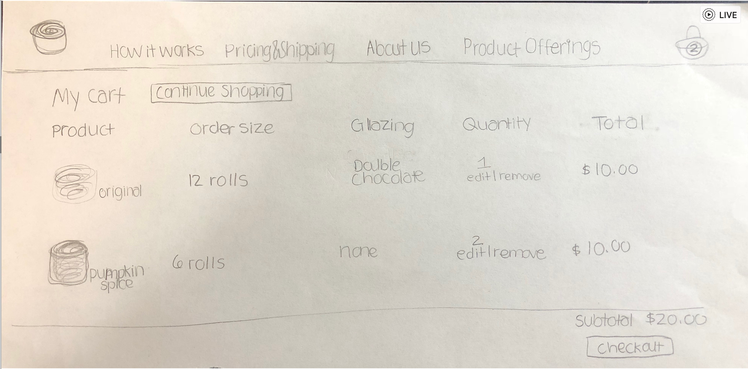

Design Choice: I looked at websites such as Amazon.com and other shopping websites to

Come up with a simple, aesthetic design that fit well with the rest of the pages. I only kept the necessary categories for the customization and avoided any extra buttons.

b. High-Fi Prototype

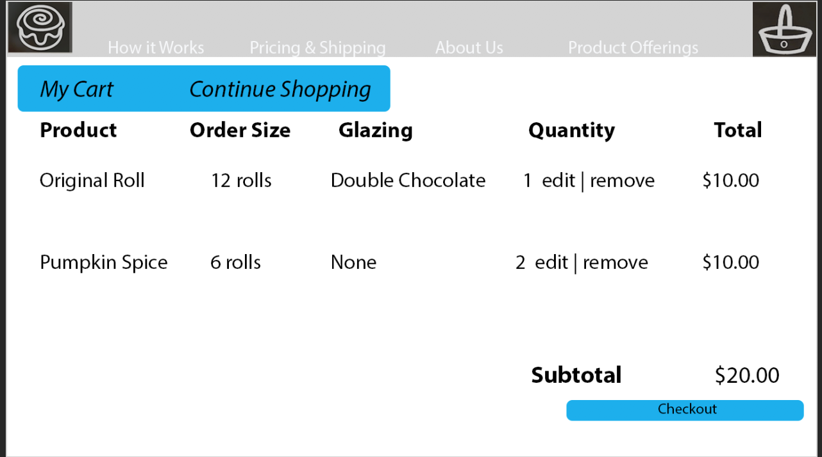

Design Choice: As mentioned, I wanted to keep a simple, aesthetic design. I also wanted the user to have freedom and control: the ability to continue shopping, go home, or add and remove entries. The color scheme is maintained from previous screens.

c. See Files for HTML/CSS Implementation

* See file cart.html // bunbun.js // cart.css // bunbun_style.css

**2. New features for your site**

a. The user can modify options on the Product Detail page (the size, quantity, etc.).

b. The Product Detail page should change according to the user’s selection.

- The user can select any of the six products from the **product offerings page (product_browsing.html)**

-The user can change the glazing and size of the order on each product page **(from any of the product offering pages)**

-Therefore, there are three key characteristics changing: type of roll, size of order, and type of glazing that are variable.

-Using a dropdown, the user can see these changes being made before adding to cart.

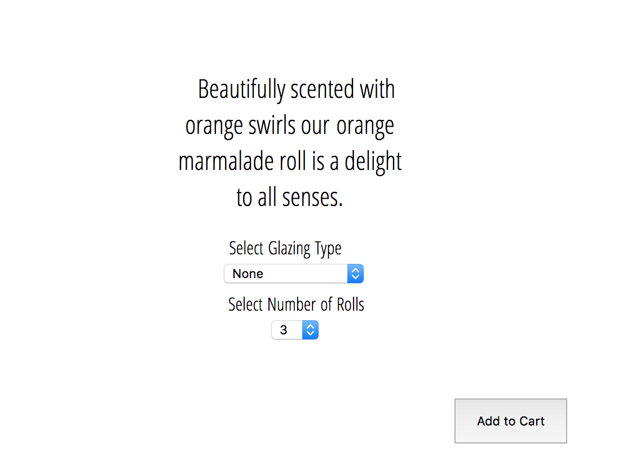

c. The user can add products to their shopping cart.

-I created a function in my js file called addToCart that allows the user to submit something to the cart

d. There should be some visual indication to the user of how many items they have in their shopping cart.

-The number in the shopping cart increases based on when an order is added to the cart



e. The user should be able to view their shopping cart on a Shopping Cart page, see the items they selected, and remove the items they no longer want.

The user is able to see the items they selected. If there are multiple size orders of the same type of item, only the quantity is increased. The “x” can be used to remove the whole item from the cart.

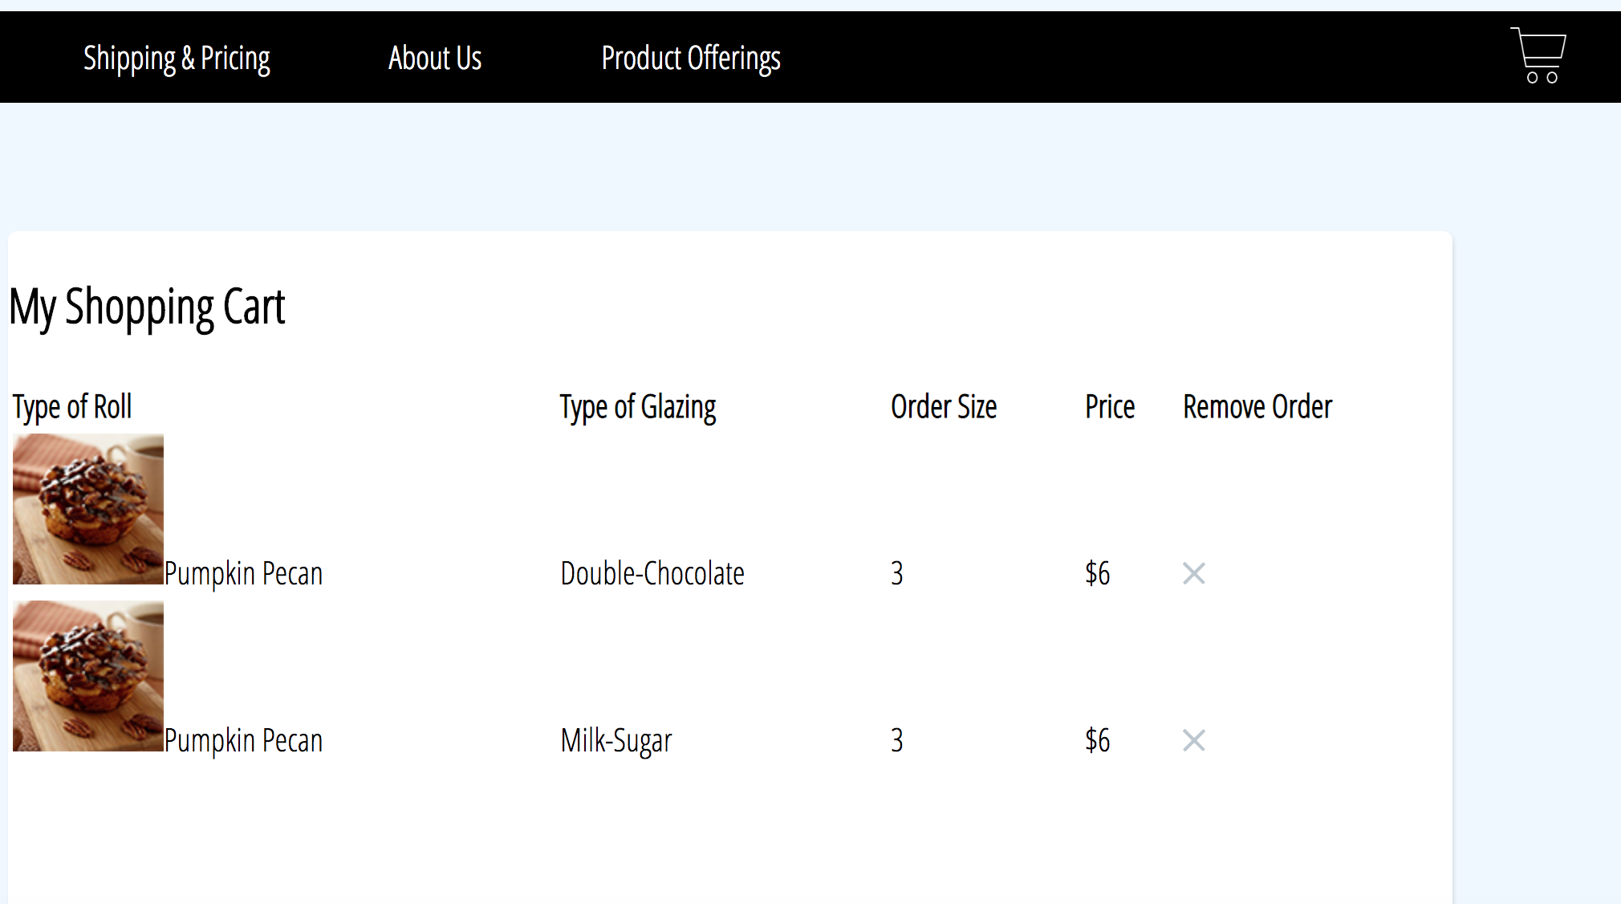

**3. Reflection**

a. Challenges/Bugs I Encountered

-Understanding how to visually see something from local storage

*I think writing down my ideas and talking out loud really helped with this

-Arranging objects into something that is visually easy to read

*Better understanding tr/td helped with this

-Learning how to use tr/td to create a dynamic shopping cart

*I used a lot of stack overflow and W3 schools to understand the syntax and what the code would look like built on a page

-Debugging syntax errors and understanding the syntax of html/css/javscript/and jquery

*I especially had a lot of trouble with making sure I didn’t miss parentheses and also had semicolons where necessary

-Having JSON errors with Parsing

-Using the functions from Javascript within HTML

*Solution: I used the onload function and did a lot of googling on understanding referencing

b. Future Implementation

* Given more time, I would have loved to create a subtotal section, and a button to both add and delete quantities by one, not just removing the whole product from the cart
* I would also want to work on making the site more visually pleasing